Introducing Simply Voting
This is the voting platform used by the AFN to conduct online voting. It makes voting online simple, convenient and secure. You can access Simply Voting on any internet connected computer, tablet, or smart phone as well as by telephone.
A number of introductions on how to use Simply Voting will be offered during the run-up to the election, including the ability for voters to take part in a “Mock Up” vote. Below these instructions are screen shots of the steps you will see when you vote.

How Simply Voting Works
- Your registration for the AFN AGA included your email address as well as your status card number (or other ID #). These will be used as part of the process for you to access the ballots on Simply Voting.
- An email will be sent by Simply Voting to all those pre-registered prior to the start of the election to note they are registered and also provide and allow for representatives to contact us if they aren’t receiving these emails.
- At 9 am EST on July 7th an email will be sent containing a link to the voting platform.
  - Links will only be sent to the representatives that were properly registered for the AGA.
- Clicking on the link in the email will take you to the Simply Voting welcome page.
  - You may login using your Status Number and Password (from the email)
- If your login was successful, you will be taken to the ballot.
  - You may select one choice on the ballot.
  - If you aren’t able to login, contact the Electoral Officer for assistance.
- Once you submit the ballot, the results are encrypted and stored in a database. Your Elector ID is then flagged as "voted" and will not be eligible to vote on this ballot again.
Voting by Phone
- Representatives may access the voting platform by telephone. This process allows for and representatives that find themselves without an internet connection the ability to cast a ballot in an alternate manner.
  - The same authentication information is required to access the vote on the phone as you would online.

Privacy and Security
Simply Voting was designed from the ground-up to minimize the risk of electoral fraud. Voters who bypass authentication or have already voted are denied access to the ballot, and ballots are checked for validity before being accepted. Nobody could ever find out what a particular voter has voted as the results are stored anonymously.
Communication between your computer and Simply Voting is encrypted with TLS 1.2. The servers are "hardened" and are routinely subjected to PCI Compliance security scans. Simply Voting application code adheres to guidelines set out by the Open Web Application Security Project.

For More Information
Please contact the AFN Electoral Officer:
Ron Laufer - Email: ronlauferelections@gmail.com Mobile Phone: 604-715-4777

EMAIL FROM SIMPLY VOTING

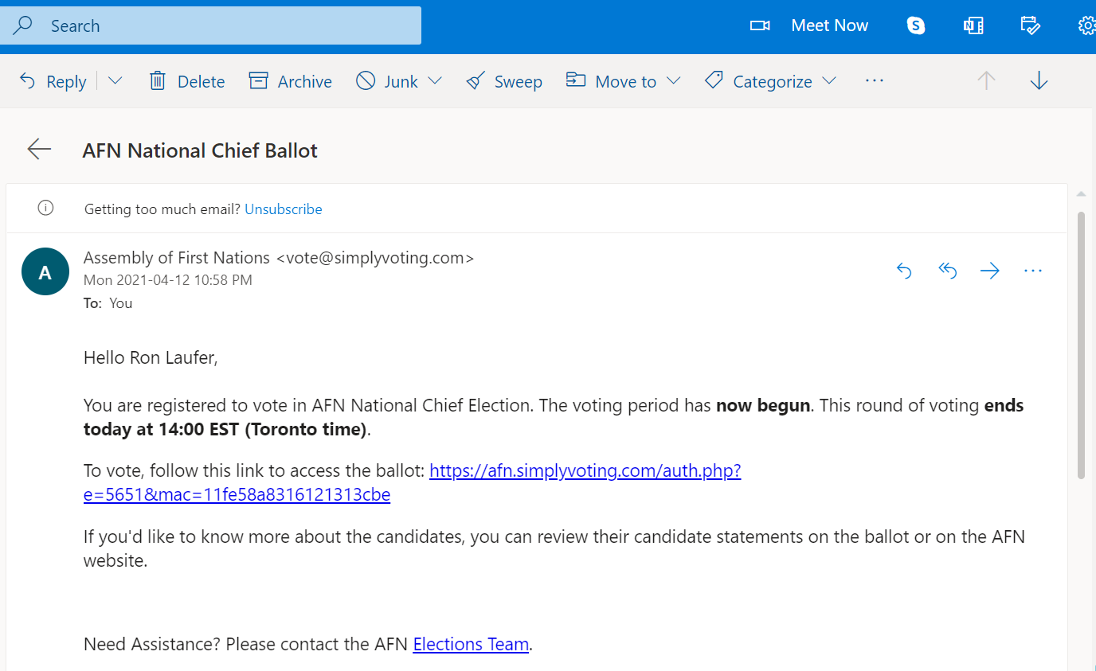

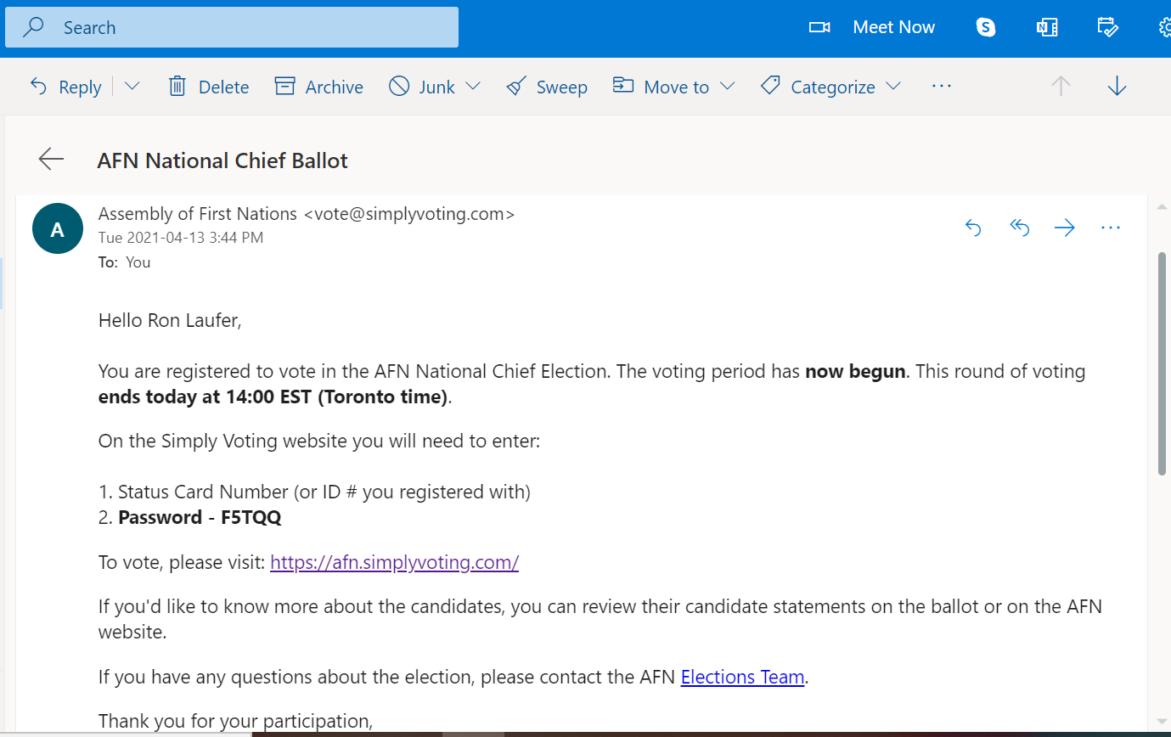

WELCOME PAGE
(Enter Status Card and Password here)

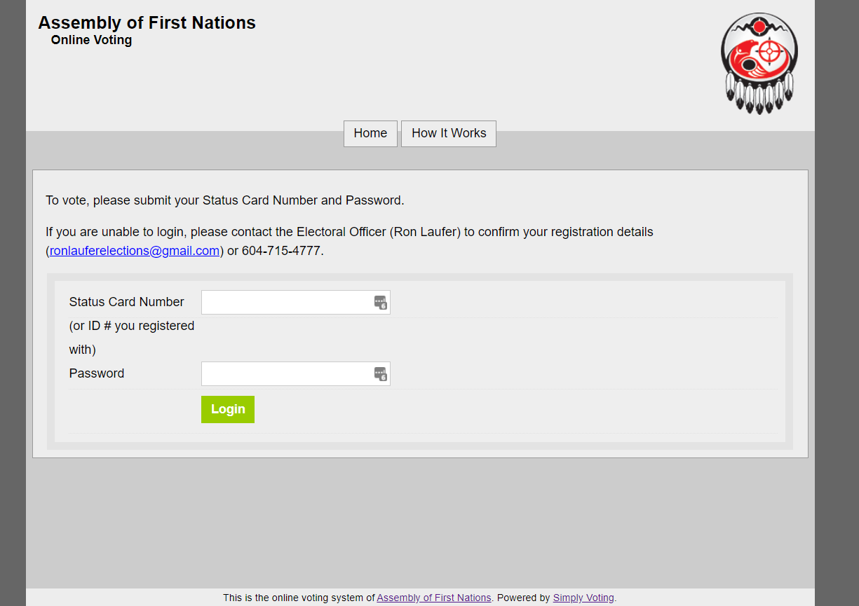

BALLOT
(Choose up to 1 candidate)

CONFIRMATION PAGE
(I abstained obviously, I’m the Electoral Officer)

VOTING COMPLETE
(Success)

